Lovpreet singh,

000848567

Product Evaluation Technical Report

Text box

**Objective:**

**This is a product evaluation report between insert features provided in MS word and libre office**

**Location:**

Word: Text box is located at **Insert >Text> Text Box.**

LibreOffice Writer: Text box is located at **Insert >Text Box.** 



And at the main bar Text Box icon

Ms. Word LibreOffice Writer

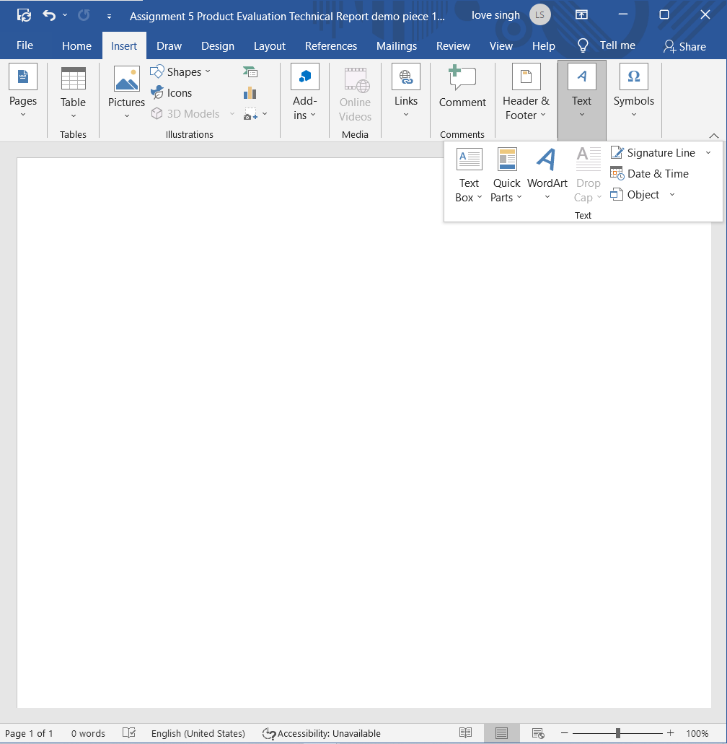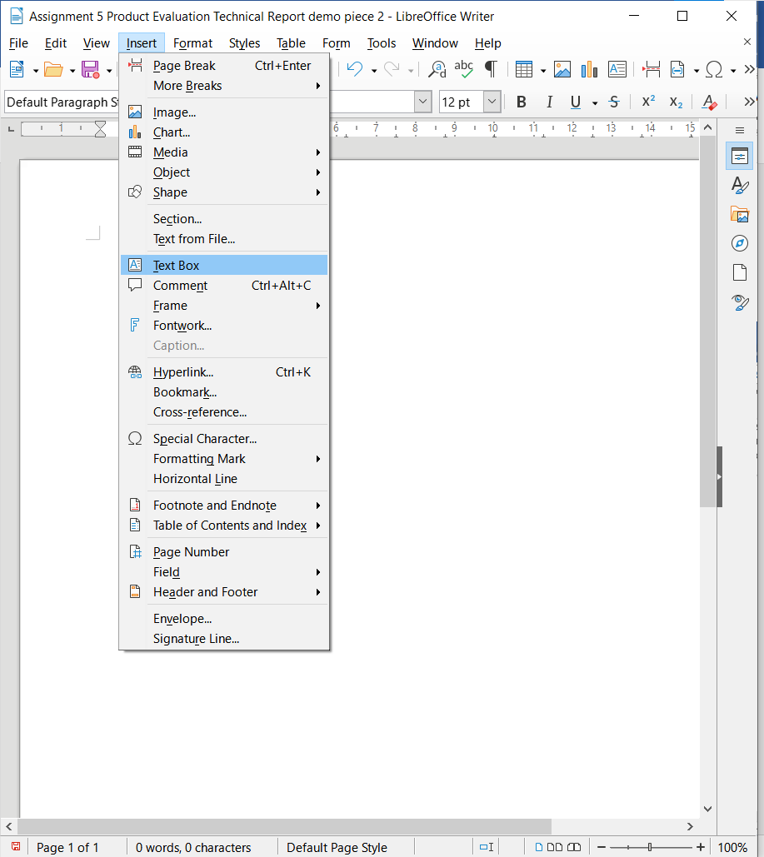

Lovepreet Singh

Lovepreet Singh

Comparison: The location of Text Box in both the applications is quite the same. But it is easy to find text box in Ms word as by clicking on insert we get a new bar instead of a dropdown like in LibreOffice writer.

Text box styling:

Word: Ms word has a lot of styling to offer such as we can get pre-selected designs that show up as soon as we click. other that there are styles like changing colours of background, border of the text box, and text, giving 3d effect and shadow to text box and many other

LibreOffice Writer: LibreOffice Writer provides text colour change and highlighting, Toggling shadow, Applying outline.

Ms. Word LibreOffice Writer

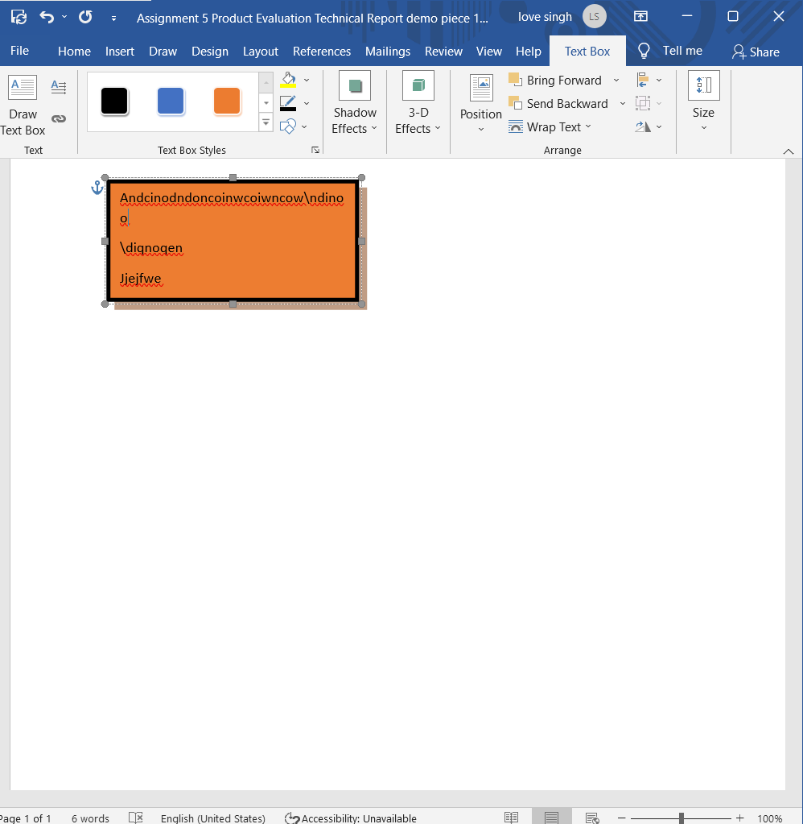 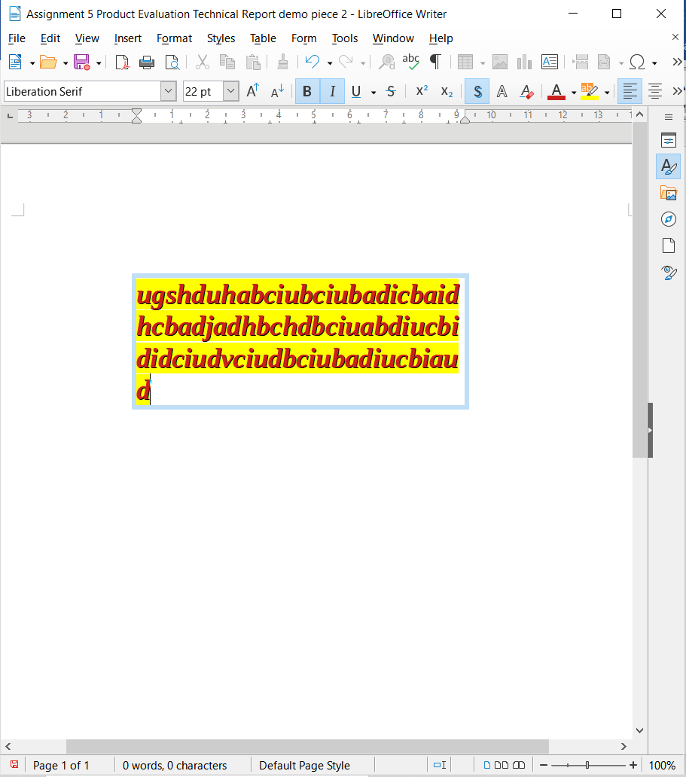

Lovepreet Singh

Lovepreet Singh

Comparison: The word has plenty more to offer in terms of styling. But In word to add text styles like bolding and changing text size we have to navigate to home while in LibreOffice it is always in the menu bar.

**My Preference:**

I would surely prefer to use Ms. Word for text boxes because it has a lot more to offer in styling and I am more organized than LibreOffice.

Table

**Location:**

LibreOffice Writer: The table is located at **Table**

Ms Word: Table is located at **Insert >Table>insert Table/ draw Table/Quick Table**

LibreOffice Writer

Ms word

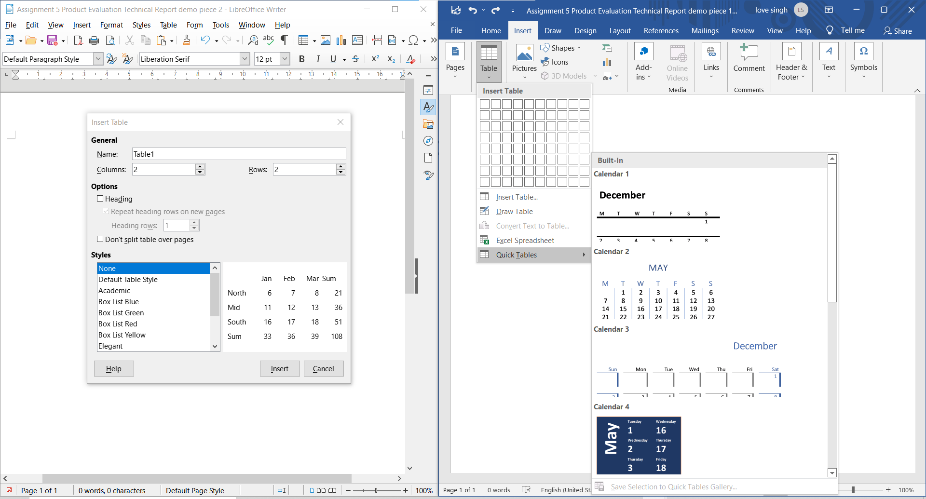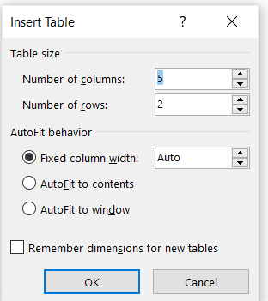

fig b.1 (Lovepreet Singh)

fig b.2 (Lovepreet Singh)

fig b.3

Comparison:

The word has several methods to add a table

1. Draw a table
2. Insert a table defining a certain number of columns and rows with options like fixed column width and more as shown in fig b.3.
3. or making a quick table with a certain design

while In LibreOffice Writer we can insert a table with

1. name
2. columns and rows
3. heading
4. and some styles (see fig b1)

Table styling:

LibreOffice Writer: LibreOffice has styles like Box list Blue/green/red/yellow/, Elegant, Financial , simple Grid column/rows, Simple List shadow. Along with making the specific rows and columns title /subtitles or simple text.

Word: Word has inbuild Styles that are very simple looking and easy to use. Word even provides an option to style the border of the table. Users can decide which column or row using he/she wants to highlight as the main column or row using the Table styling options as shown in fig c1

LibreOfficeWriter

Ms word

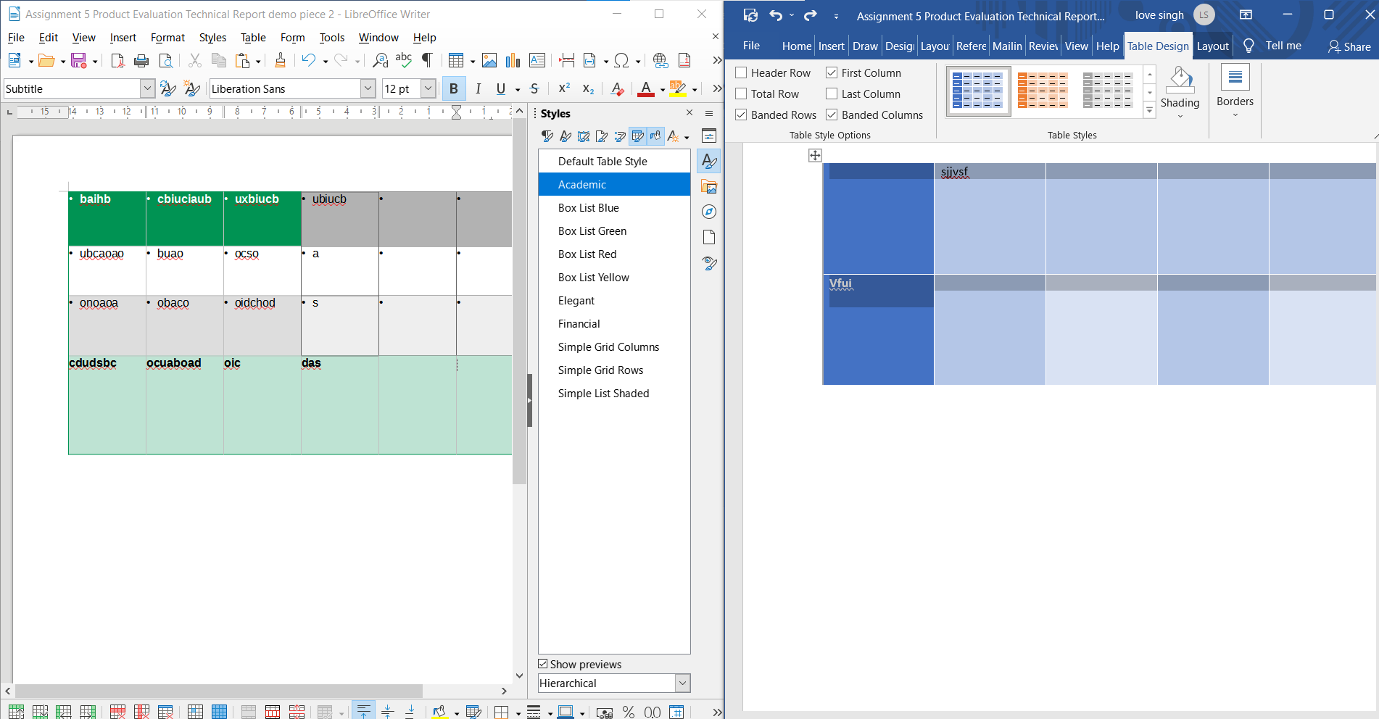

Lovepreet Singh (figc1)

Comparison: Word has more clarity in styles than LibreOffice

**My preference**:

I believe Word is better for creating a simple table as it provides more preselected designs and options than LibreOffice Writer. Word provides an option to select our shading of the table which is not there in the case of LibreOffice Writer. The border styling feature is only available in word.

Charts

**Location**

LibreOffice Writer: The table is located at **chart icon** (SEE highlight in figd1)

Word: Table is located at **Insert >Chart icon** (SEE highlight in figd1)

**Charts available:**

Types of charts available in LibreOffice Writer:

* column
* bar
* pir
* Area
* Line
* XY(scatter)
* BUBBLE
* Net
* Stock
* Column and line

Types of charts available in MS Word:

* column
* bar
* pie
* Area
* Line
* XY(scatter)
* Map
* Stock
* Surface
* Radar
* Tree MAP
* Sunburst
* Histogram
* Box& Whisker
* Waterfall
* Funnel
* Combo

Comparison: There are more chart types available in word than LibreOffice Writer

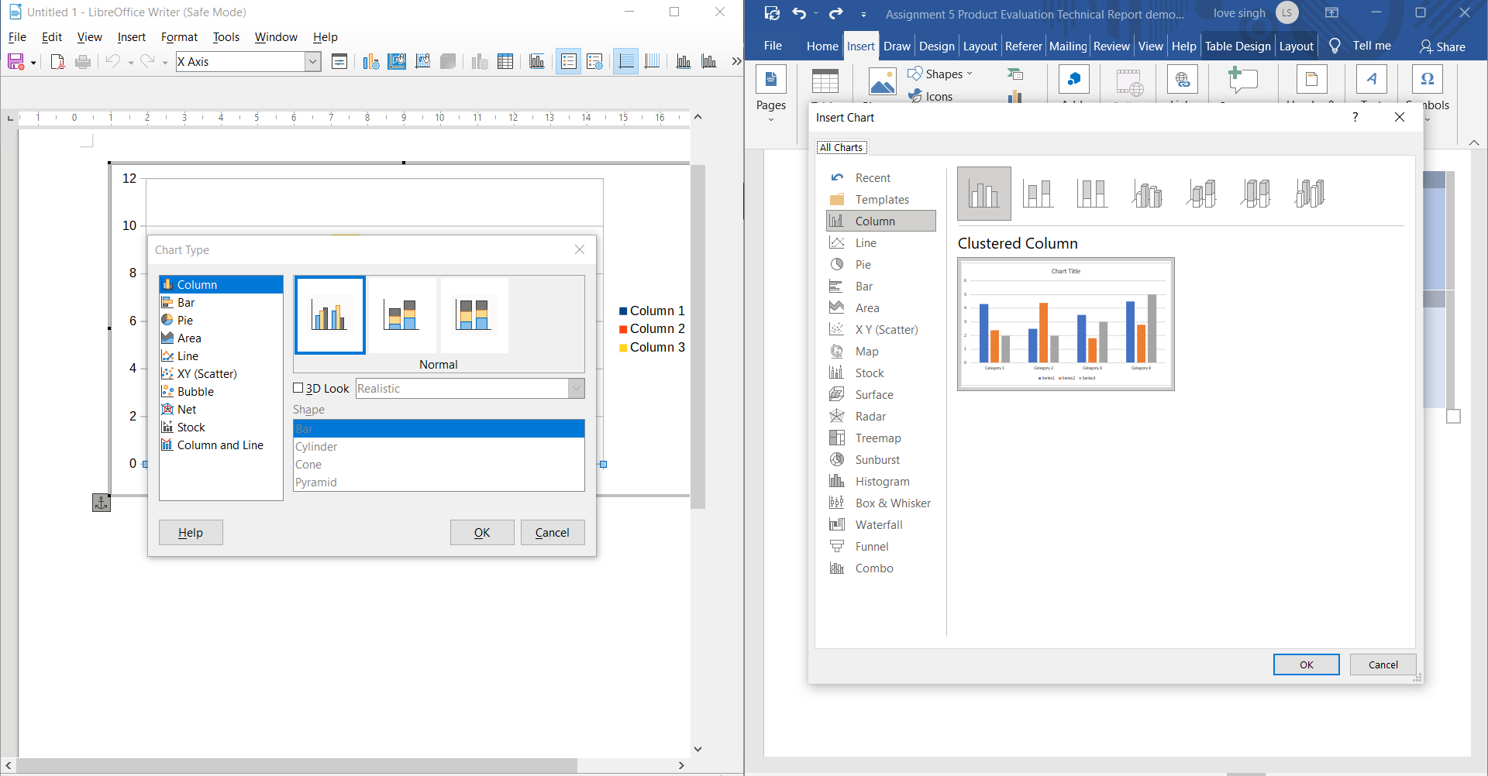



Fig d1(lovepreet singh)

Entering data:

LibreOffice Writer: for entering stats we have to click on the data table icon (highlighted In fig 4b)

MS Word: Ms word provides us with an excel spreadsheet for entering data and changes.

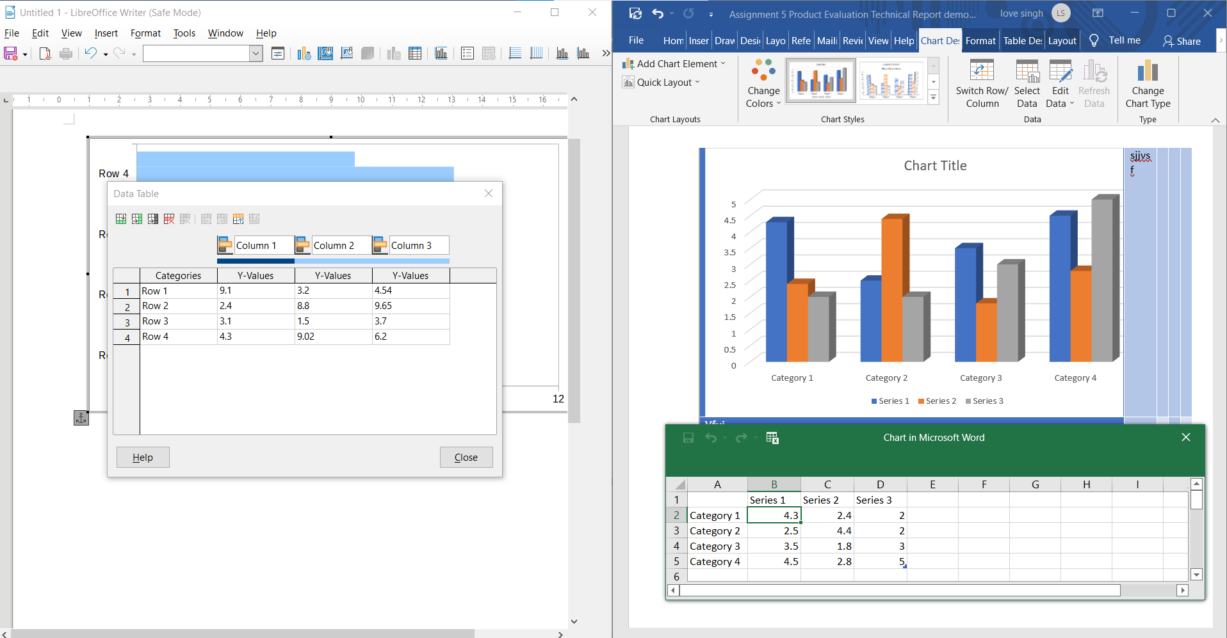



Fig b4 (lovepreet singh)

Comparison:

Entering data is much better in MS Word as through excel we can apply the formulas for calculating stats which we can’t do in LibreOffice Writer as it only allows numbers to be written in stats.

Preference :I personally would prefer to use Word for making Charts because if I need to make chart I need more styles and my should be more organised which is more easily attainable in Word than LibreOffice.

Shapes

**Location**

LibreOffice Writer: Shapes are located at **Insert > Shape**

MS word: Shapes are located at **Insert > Shape**

Shapes available in LibreOffice Writer:

* Line
* Basic shapes: rectangle, square, circle,
* triangle and many more
* Symbols shapes
* Stars and banners Callout shapes
* Flow Charts

Shapes available in MS word:

* Line
* Basic shapes:
* Block Arrows
* Stars and banners
* Callout shapes
* Flow Charts

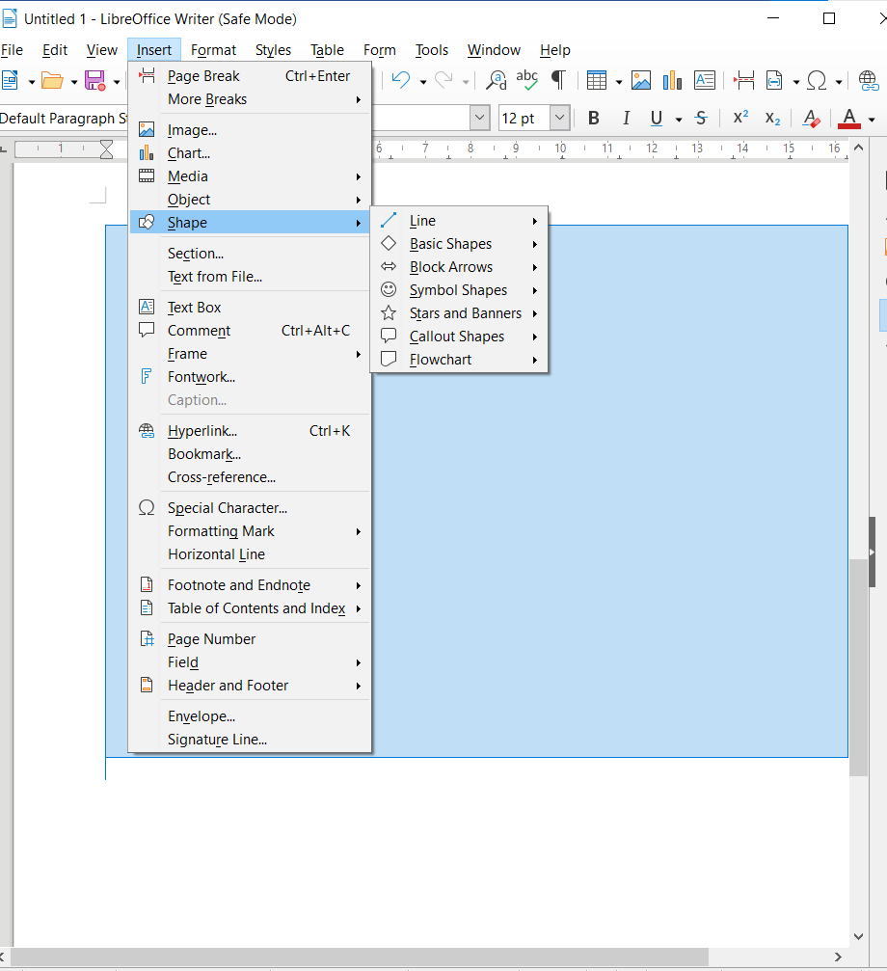 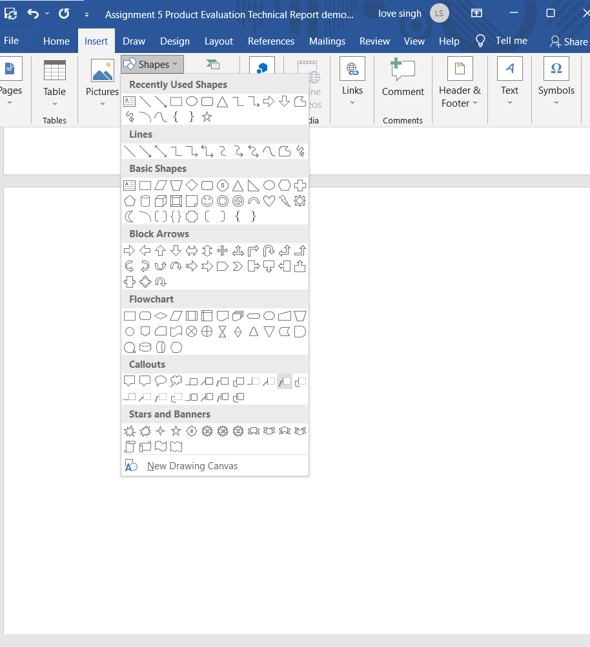

Fig e1(lovepreet singh)

Comparison: Word has more shapes than LibreOffice Writer, word also provides recently used section which is great as now we no longer need to walk through all of the shapes to find the one that we used last time . Word also displays the visual image of the shape which not there in LibreOffice Writer.

Preference: I personally would prefer to use Word for making Shapes in my document as it has more visual information than LibreOffice Writer

Conclusion

My Overall Preference: Word has been better in both comparison and preference in all four features: table, chart, shape, textbox so I believe it is not biased to say that Ms word is way better than LibreOffice Writer

Reasons for Ms word being better in all 4 are:

**More options**: Ms word was having more options than LibreOffice Writer in every aspect. Pre-Prepared styles, shapes, charts were a lot more in word than LibreOffice Writer. This reduces the pressure of making their document look nice form user which of course save time and thinking. With having more options to style the user can focus more on the data itself. Also having a variety of charts and shape eliminate the aspect of compromising.

**Easy travel**: Accessing the feature was more easy fin MS word than in LibreOffice Writer. LibreOffice Writer was not having as good visual appeal as Ms Word. Accessing a figure from a small pointer size icon was very difficult and along with that the responsive design of the LibreOffice Writer was not satisfying as it tends to reduce the menu bar making a single icon to access the features in the right side through dropdown while in case of word feature locations were easy to find and not compromised on reducing screen.

**Contact with other platforms of Ms**: The MS word had the access of the other platforms like excel even when I was using word while making charts which is very impressive as I could use the formulas and features of excel to enhance my perform and chart management. None of this was available in LibreOffice Writer. I had to type my already calculated values to make chart which is quite boring